INTERNATIONAL POLICE ASSOCIATION
FIRST FOLKLORE FESTIVAL

„FORGET- ME - NOT“
2019

04th - 08th September 2019 in Bulgaria, Chepelare
Program
- Arrival of guests is planned for 04th September 2019.
- The formal opening of the Festival will take place on 05th September 2019. At the ceremonial opening there will be a parade and it is necessary to come in the traditional costumes of the country you represent and bring a flag of the country you represent.
- The festival activities will take place on 05th and 06th September. The schedule of the presentations will be subsequently determined for each delegation, depending on the number of delegated delegations, and you will be informed on it in a timely manner.
- On 07th September 2019 a free whole-day trip will be organized for the guests. The time for the trip will be determined later, when we will have information about the number of participants in the event, about which you will be notified in a timely manner.
- Closing the festival and the final gala dinner will be held on 07th September 2019.
- Departure of guests is planned for 08th September 2019.

Guests who, due to organizing a trip or because of their desire to stay longer in our country, come earlier or stay longer than it was indicated, can stay in the hotel where the Conference will be held at a more favorable price than the regular one.

Each delegation (country) will have a stand to represent souvenirs and materials from the particular country. The participants have to wear traditional costumes. A song, a dance, a melody or a tradition has to be presented. Of course, a good mood is a condition for participation. The singers and the dancers can use music recorded on CDs, memory sticks, etc.

It is NOT a competition for the participants, it will be a competition for the photographers and videographers. The idea is for the photographers to take a lot of photos and the videographers to film a lot of situations. IPA - Bulgarian Section will spread all of them and International commission from IPA members will choose the winners. They will be awarded on the 64th Congress of IPA in October, in Croatia.

Bulgarian Section will invite professionals from the TV to film the event and will disseminate it all over the world.

Invitation for the Festival is addressed to both IPA members and family members, because the purpose of the event is to involve more people and to celebrate the friendship in festal environment.

Number of participants is not limited.
Deadline for registration is 15th May 2019.

Also we want to organize a competition for the Logo of the Festival - the rules will be spread in January, the dead line will be the end of May and the results will be known in the end of June. The winner will be awarded on the closing ceremony of the festival.

Because of the symbol of police officers - blue line we choose the name of the event to be
„FORGET-ME-NOT“ - FIRST FOLKLORE FESTIVAL - BULGARIA 2019

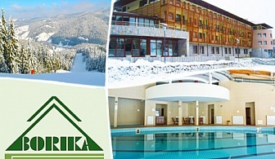

The price of a five-day package in a double room is 260,00 Euro per person.
The price of a five-day package in a single room is 300,00 Euro per person. Package price includes:
- Five overnight stay in a superior room, with breakfast, lunch and dinner;
- Various opportunities for complete relaxation and quality rest in modern sports center. The center has a professional fitness and massage facilities, an indoor swimming pool 22 m long and 15 m wide, a separate pool for children 6 m long and 3 m wide, two saunas, two steam baths, jacuzzi;
- Wireless Internet access is available in the hotel foyers;
- Residence tax;
- Transport - from airports of Sofia and Plovdiv;
- There is also a large parking lot available for the hotel guests.

More information about the hotel can be found at: www.borika.bg
Should you need anything that is not included in the package price, please contact us at the e-mail address: first.folklore.festival2019@gmail.com
Should you need transportation that is not included in the package price (bus stations, railway stations, local transport, organizations of individual excursions or other modes of transport), please contact us at the e-mail address: first.folklore.festival2019@gmail.com

Payment instructions: The deadline for payment of the full amount is 15th July 2019.
Payment is done in euros. Bank taxes have to be paid by the participants.

Bank details:
Bank: UBB (United Bulgarian Bank)
Account owner: IPA - Section Bulgaria
Account number: BG68UBBS88881400259066
IBAN: UBBSBGSF.

Cancellation Policy:
Cancellation before 01st July 2019 - full return of payment minus bank fees.
Cancellation between 01st July and 30th July 2019 - refund of 75 % of paid fee minus bank fees.
Cancellation between 31st July and 28th August 2019 - refund of 20 % of paid fee minus bank fees.
Cancellation from the 29th August 2019 no refund.

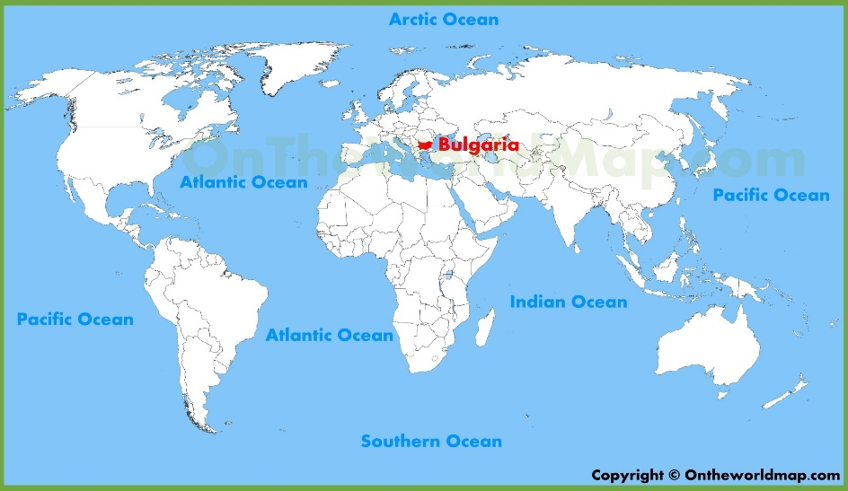
Bulgaria is located in Southeast Europe, in the northeast part of the Balkan Peninsula. Its territory is located between 44°13’ and 41°14’ north latitude, 22°22’ and 28°37’ east longitude. It is a European, Balkan, Black Sea and Danube country. This geographic location places it on the crossroad between Europe, Asia and Africa.
The country’s geographic position determines the relatively wide angle of sunlight that falls on the country, making the country predominantly sunny. The official time in Bulgaria is Eastern European Time, which is two hours ahead of Greenwich Time. The Black and The Danube River influence the country’s climate. Bulgaria’s favorable geographic location creates excellent preconditions for the development of tourism.
Bulgaria is also a transport crossroad, affording access to Western Europe, the Near East and the Middle East, and the Mediterranean. A series of major European transport corridors pass through Bulgaria.
The total length of Bulgaria’s borders is 2,245 km. Bulgaria borders to the north with Romania, to the east with the Black Sea, to the south with Turkey and Greece, and to the west with Republic of Macedonia and Serbia.
According to its Constitution, Bulgaria is a Parliamentary Republic, a unified state with local self-government. The official language in the republic is Bulgarian, and the religion of most Bulgarians is Eastern Orthodox Christianity. The national state emblem of the Republic of Bulgaria is an upright golden lion on a dark red, shield-shaped background. The national emblem of Republic of Bulgaria is depicted on its state seal. The flag of the Republic of Bulgaria consists of three colors: white, green and red, laid horizontally from top to bottom. The country’s national anthem is the song Mila Rodino (Dear Motherland). Bulgaria’s capital is Sofia. Since 1 January 2007, Bulgaria has also been a member of the EU.
The natural landscape of Bulgaria is diverse, consisting of lowlands, plains, foothills and plateaus, river valleys, basins, and mountains of varying elevations. About 70% of the country’s territory is hilly land and 30% is mountainous. The average elevation of the country’s territory is 467 m, generally decreasing from south to north and from west to east.
While traveling around the country, tourists will become acquainted with various rituals and customs, many of which are typical only for specific regions in Bulgaria.
Bulgarians have developed their culture and enriched it over the millennia, and they preserve it and continue to develop it to the present day. In more recent times, Bulgarians have also had reason to take pride in their literature, arts, music, and architecture. A proof of ongoing involvement is Bulgaria’s rich cultural calendar of national and international festivals for young and old alike, as well as other gatherings, cultural events, and expositions.
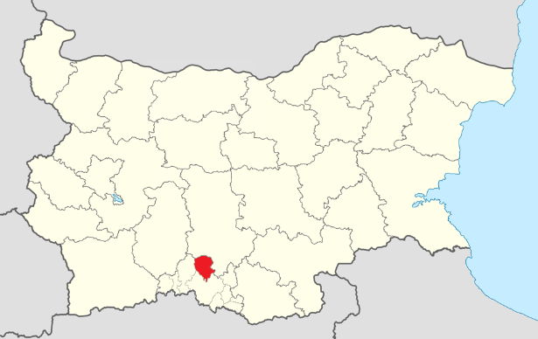

City of Chepelare is situated on the two banks of the Chepelarska river, at the very south-eastern foots of the Chernatitsa Ridge. The average altitude is about 1150 m above the sea level. Fresh mountain air and the unique wind called foehn, comming from Aegean sea have negative ionization. This makes the stay in Chepelare extremely propitious for people with lung disease.

We recommend Sofia Airport as your international airport.

Transfer will be arranged.

In case of emergency - Police, Ambulance or Fire Call 112.

Travel insurance: All participators are requested to arrange fully covering private travel insurance.

The Executive Board of IPA - Bulgarian section welcome IPA members and family members all over the world to the First Folklore Festival - Forget-me-not 2019. We are looking forward to meet you in Chepelare between 4th September and 08th September 2019.

In friendship,

Ognyan Bogoev
President of the IPA - Bulgarian section

Servo per Amikeco!

REGISTRATION FORM (one for each participant)

Name: .................................................................................................................................................................
Postal Address: ...................................................................................................................................................
Mail: ..................................................................................
Mobile number: ............-...................................................
Country: ............................................................................
Function: ...........................................................................
Alternative: .......................................................................

Select:
Double room/Single room/Shared Double room
Name with whom you share the double room: ...................................................................................................
Your participation is as: delegate/observer/guest/invited guest/ spouse
Arrival date:2019 - September - ….. at ….. hour
Departure date:2019 - September - .…. at ….. hour
Additional night: 2019 - …………….-…..

Diet:.....................................................................................................................................................................
Allergy:................................................................................................................................................................

Date ........................... Signature: …….....................................

The Registration Form is to be forwarded at latest on 15th May 2019 via e-mail:
first.folklore.festival2019@gmail.com

First Folklore Festival „Forget-me-not“ 2019

